# Microsoft Lync

* 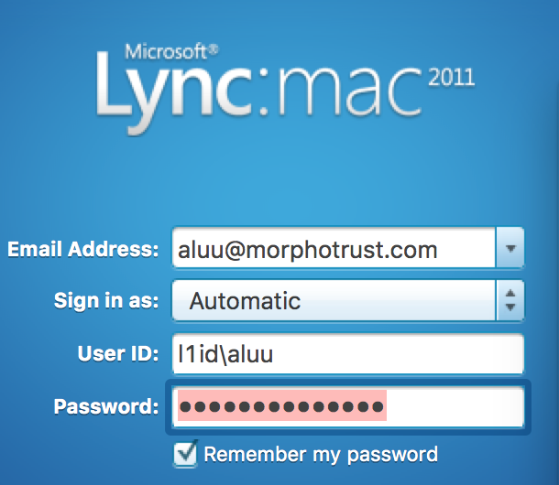

# Troubleshoot

## Sierra upgrade issue

Ferwerda, Scott·11:29 AM

If anyone @here is having problems with Lync: open Keychain Access, go to login -> Certificates. Find the ones for l1id-MNDC01-CA and [scd-lyncpool1.l1id.local](http://scd-lyncpool1.l1id.local/), and mark them "Always Trust".

That seemed to fix my Lync signing issues, anyway. Though now I get prompted for accessing something weird in the keychain. I just cancel it and Lync works.